Login to AWS dashboard, and go to us-west-1 region

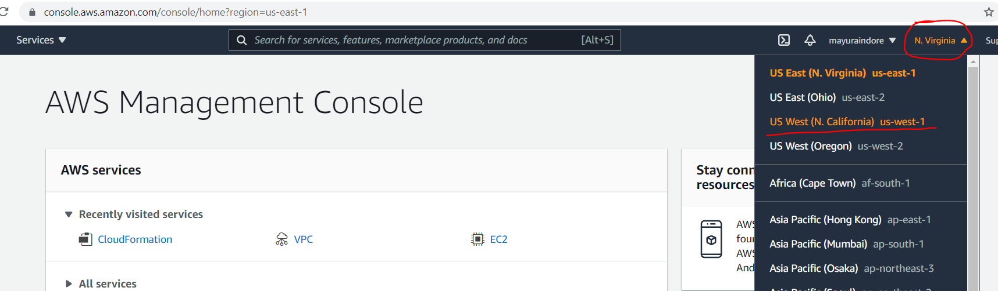

In search bar, type cloudformation and click on it.

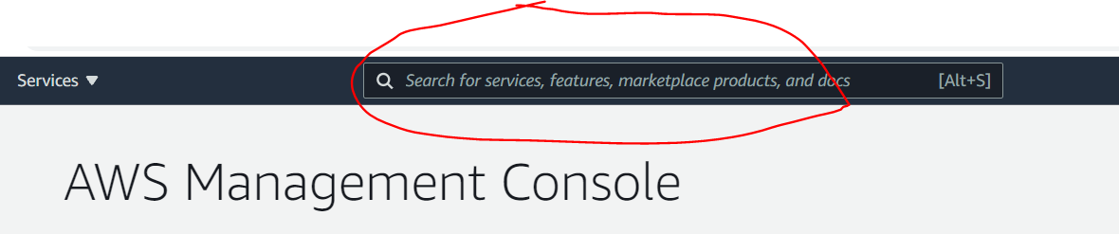

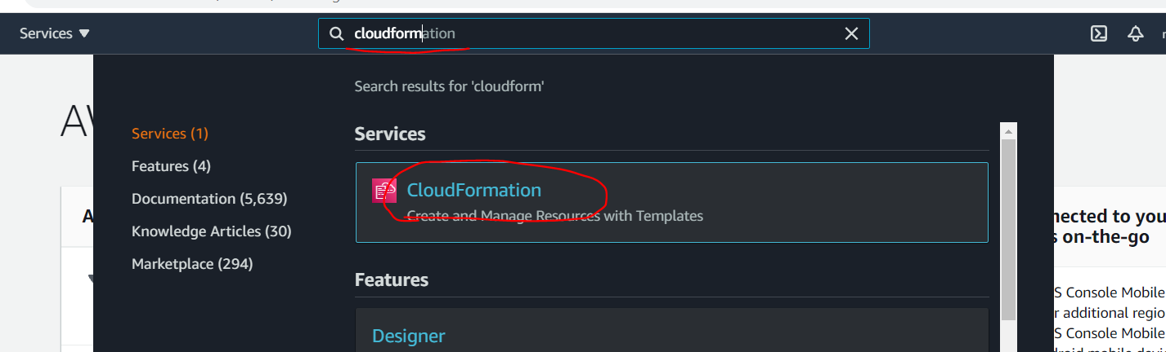

Click on “**Create Stack**” and then “**With new resources**”.

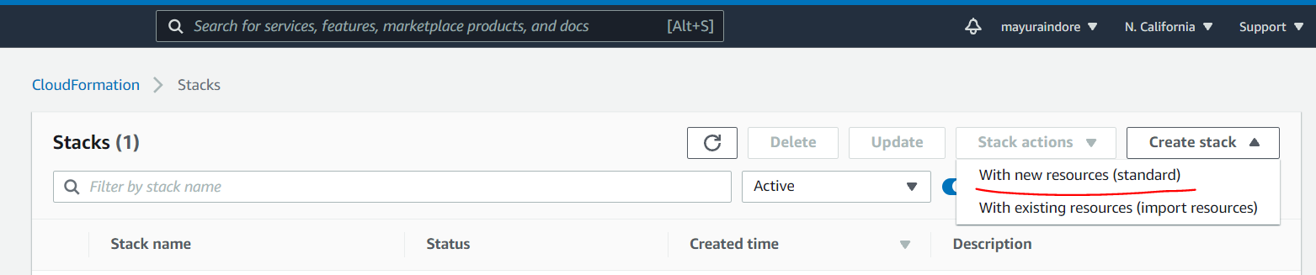

Follow 1,2,3,4 steps

1. Select **Template is ready** option
2. Select **Upload a template file** option
3. Click on **Choose file** and provide yaml file cloudformation template shared with you.
4. Click on **Next**

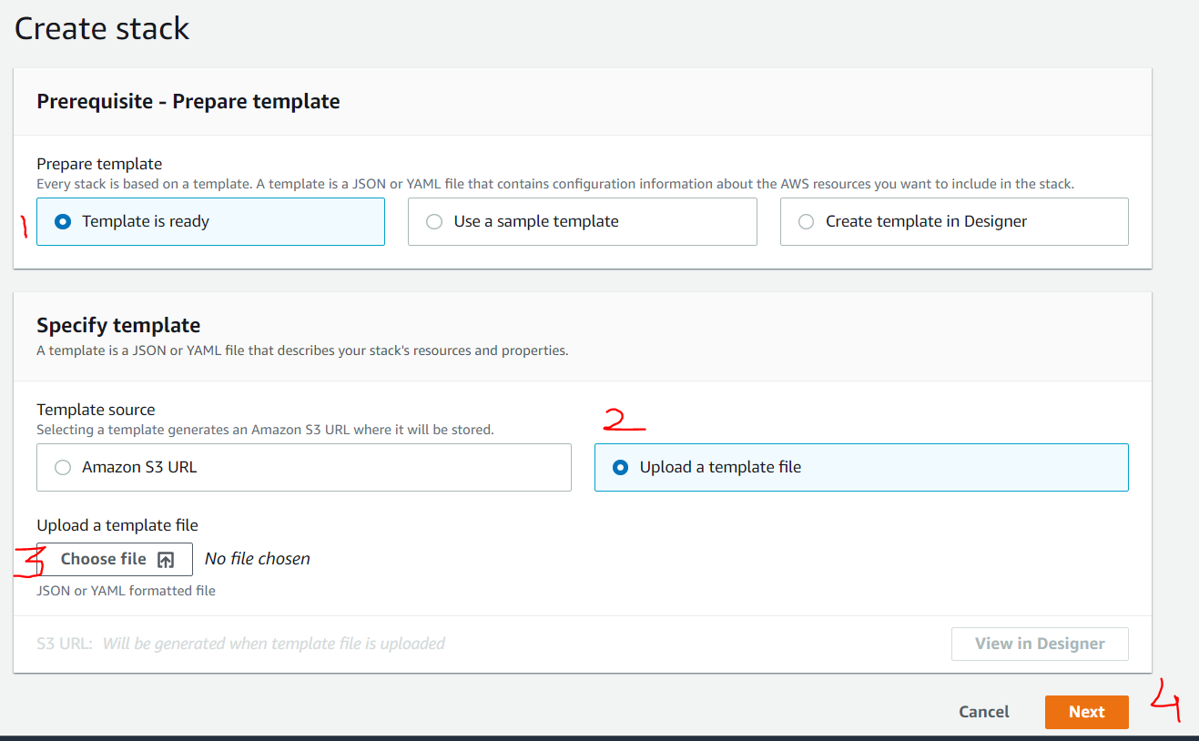

Provide information

Stack Name –--> **DEVOPS-VPC**

VPCNAME –--> **DEVOPS**

VPCCIDR –--> **10.10.0.0/16**

DEVSUBCIDR –--> **10.10.10.0/24**

QASUBCIDR –--> **10.10.20.0./24**

PRODSUBCIDR –--> **10.10.30.0/24**

DRSUBCIDR –--> **10.10.40.0/24**

Click on **Next**

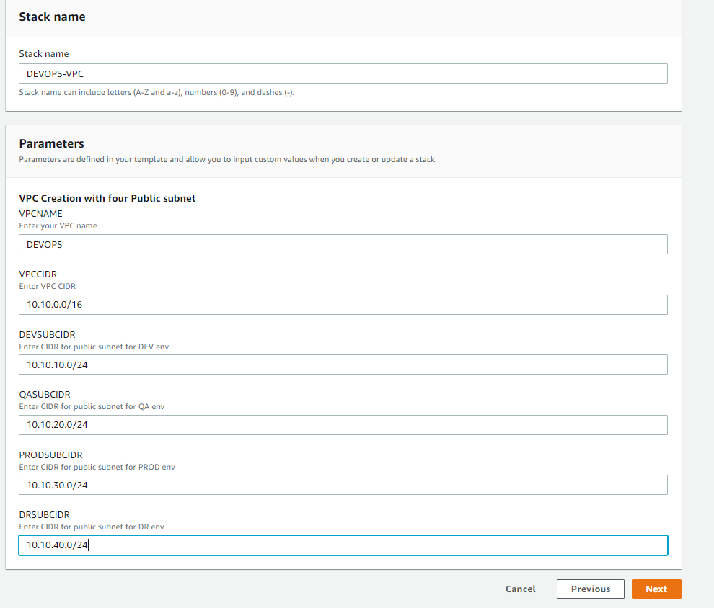

Click on **Next**, no need to make any changes.

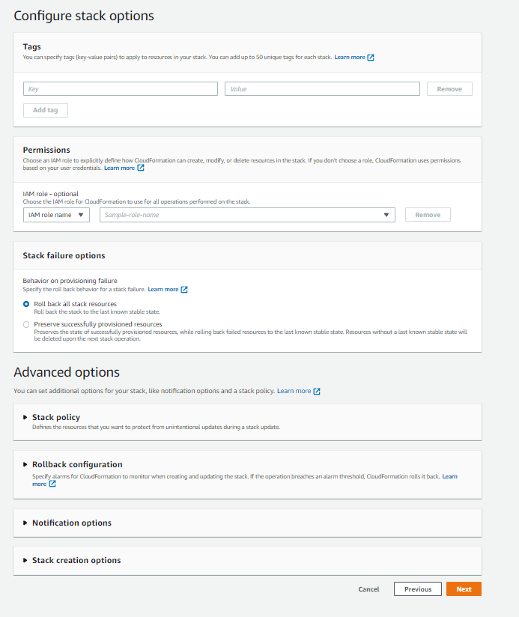

Review page, just do click on **Next**.

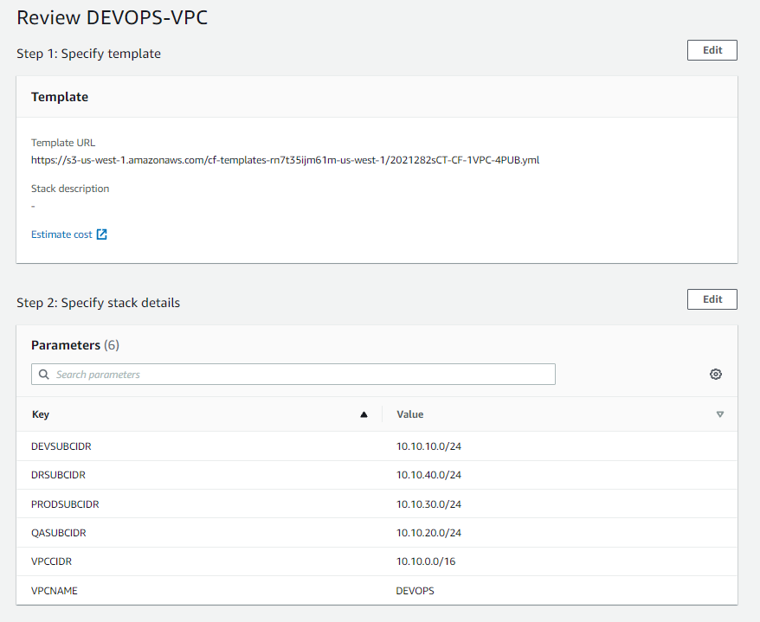

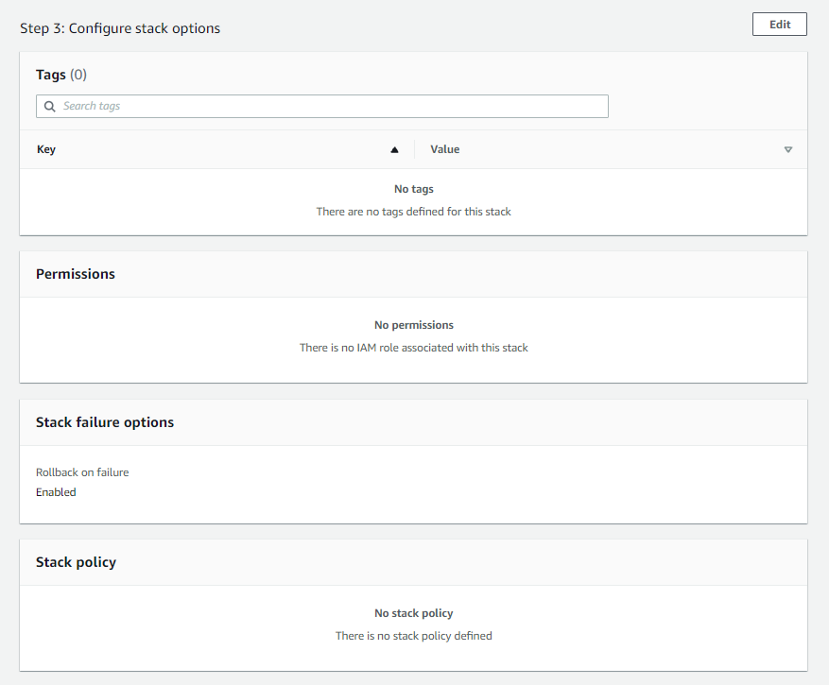

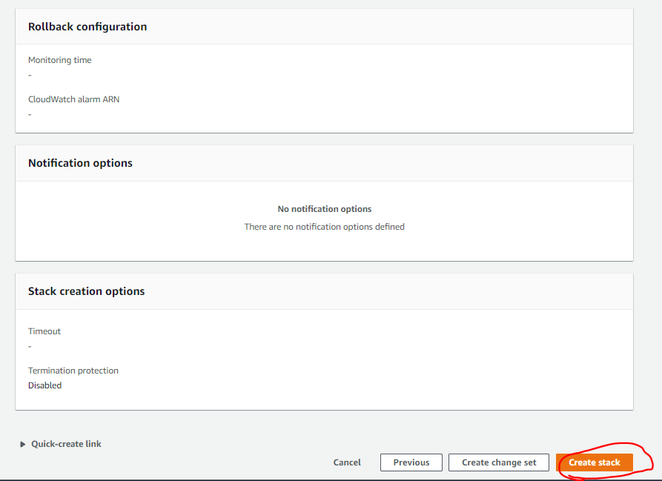

You can click on refresh button, and wait to complete stack creation.

